### Market Segmentation Report: Vehicle Body Type In india

1. Machine Learning Model Used in Project.

In this project, The ARIMA (AutoRegressive Integrated Moving Average) model was implemented as the primary algorithm to understand and forecast patterns in electric vehicle (EV) trends over time. ARIMA is a powerful time series forecasting technique, particularly well-suited for structured, chronological datasets like vehicle specifications across manufacturing years.It works on the previously known records and predict the forecast accordingly.

###### Final Conclusion and Insights Gained

The most popular EV vehicle body type observed was **Scooter**, followed closely by **Cars** and **Bikes**.

From a forecasting perspective, the ARIMA model highlighted how the demand of vehicle vary in next five years[according to vehicle body type]

Insights include:

Scooters dominate the EV market in terms of sheer numbers. Scooters are easy to handle and easy to maintain,it can be used for daily commuting purpose it is perfect choice for middle class family to enter in EV vehicle world.

Car are on second rank,as technology is increasing the EV cars are getting affordable.EV cars can be a good option for those people who spend most of their time on city road and in traffic, they are less polluting and handles intracity duties very well, but lack for long distance travelling duties.

Car has more sub body type: Crossover,Sedan, MVP,SUV, Hatchback.

According to data, Crossover is the most popular body type among the indians.

Contribution of Car body type in Indian market :

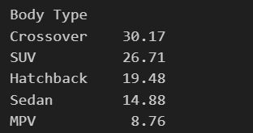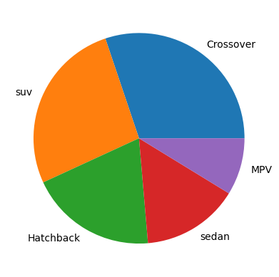

After analyzing and comparing the data of 2010 - 2015 with the data of 2016 -2023 , we got insights :

| **Body Type** | **Before (%)** | **After (%)** | **Change (Δ%)** | **Change Type** |
| --- | --- | --- | --- | --- |
| **Crossover** | 29.77 | 30.46 | **+0.69** | Slight Increase |
| **SUV** | 26.66 | 26.74 | **+0.08** | Negligible Change |
| **Hatchback** | 19.52 | 19.45 | **−0.07** | Negligible Decrease |
| **Sedan** | 15.53 | 14.41 | **−1.12** | Noticeable Decrease |
| **MPV** | 8.52 | 8.93 | **+0.41** | Small Increase |

According to Research & Indian road conditions ,people are turning towards vehicle that combines features of a traditional car with those of an SUV . The crossover just falls between car and suv.

Some of the famous crossover in India are: Hyundai Creta, Maruti Brezza.

###### Potential Improvements with More Time & Budget

The project could be significantly improved if the dataset contains more data, such as vehicle fuel type, vehicle maintenance cost etc

It will make it more easy to understand the peoples demand and their choice. If the budget is more we can definitely spend it on data collection and data mining.

Additional ML Models to Explore:

* XGBoost and LightGBM for improved classification performance.
* SARIMA (Seasonal ARIMA) to model cyclic demand (e.g., festival or fiscal year effects).
* K-Means or DBSCAN for feature-based market segmentation.
* LSTM (Long Short-Term Memory) neural networks for deeper time series forecasting.
* Association Rule Mining to find patterns between features and customer preferences.

###### Estimated Market Size – EV (Electric Vehicle) Industry

Global Market Value (2023): USD 388 billion

Forecasted Market Value (2030): USD 950+ billion

Compound Annual Growth Rate (CAGR): 13–14%

Vehicle Volume: Over 14 million EVs sold worldwide in 2023

1. **Github link :**

https://github.com/Riteshdeshmukh22/EV-vehicle-body-type-market-analysis-.git